How to Launch Your Masternode Using Snapshot Files

Version 1.1

Table of Contents
How to Launch Your Masternode Using Snapshot Files 1
Version 1.1 1
1 Introduction 2
1.1 Purpose of this guide 2
1.2 Definition 2
1.3 Finish syncing before launching with snapshot 2
2 Launch Snapshot for Linux, Windows and Mac 3
2.1 Linux 4
2.2 Windows 7
2.3 Mac 11

Introduction

Purpose of this guide
This guide details how to launch the Matrix Mainnet using snapshot files.

Definition
Snapshot: trustable foundational data in the Matrix Mainnet

Finish syncing before launching with snapshot
Snapshot block height is lower than Mainnet block height. Therefore, syncing data is necessary. If a node is staked, it will take some time to sync the node to the latest block in the mainnet before it is possible to launch the node using snapshot.
For this reason, to avoid suffering losses, it is recommended to finish syncing on a separate computer and then transfer your data onto it.
To do this, sync to the highest block on a different node that is not staked. Then close gman on your original computer and transfer all data to the already synced new node. Relaunch the new node.

Launch Snapshot for Linux, Windows and Mac
Instruction is given here on how to launch your Masternode using snapshot on Linux, Windows and Mac.

NOTE: The naming strategy of a snapshot file is as follows:
chaindata + (the actual block height on the Mainnet).tar.gz.

Take chaindata1342516.tar.gz for example. The number in the file name reflects the real-time block height on the Matrix Mainnet. Please make sure you download the latest file by checking if the name matches the snapshot height that is announced.

The pictures below only show the snapshot height in the test environment. Please know that the actual snapshot height you get will be different.

Linux
2.1.1 Download the latest version of gman at www.matrix.io/dropdown_lord_cn.html. (The same package works for both Linux and Mac.)

2.1.2 Download the latest snapshot file zip package at the address below.
www.matrix.io/assets/dropdown/TrieData5900000.tgz.

2.1.3 Decompress the snapshot file zip package to the snapdir folder under the same directory in the gman folder. Here let’s take decompressing tar xvf chaindata1342516.tar.gz as an example.

2.1.4 Launch the gman syncing module by running the command below.
./gman --datadir ./chaindata --networkid 1 --debug --verbosity 5 --gcmode archive --outputinfo 1 -- syncmode full --loadsnapfile "TrieData1342516 "

2.1.5 Check if blocks are syncing.
a）Run ./gman attach ./chaindata/gman.ipc to launch IPC.
b）Run eth.blocknumber to check if blocks have started syncing. Snapshot height can be seen from the snapdir folder.
c）Run net.PeerCount. View the number of peers. If there are no connected peers for five minutes, close gman and repeat the previous step. If there are connected peers, check if data is syncing.
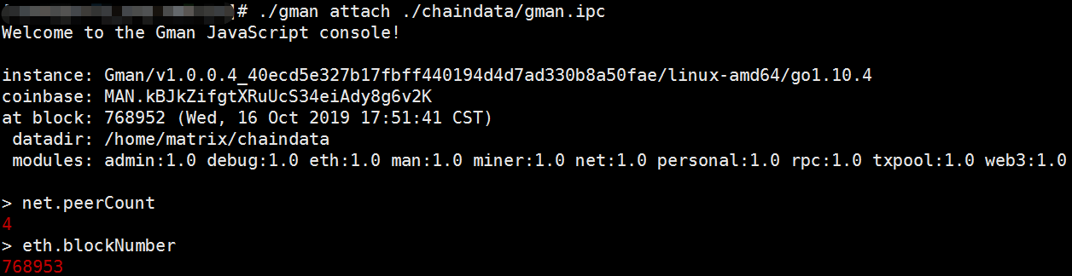
2.1.6 Transfer account data
- Copy the keystore data file from the original computer. The keystore file can be found under the keystore folder. The keystore folder can be found under the chaindata folder, which in turn is under the gman folder.
- Find the entrust.json file in the gman file of the original computer. Copy and paste it in the gman folder of the new computer.

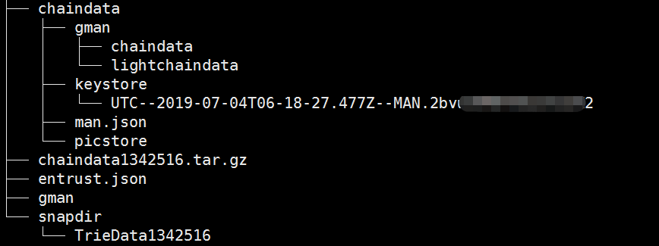
- Close the old gman file.
- Launch gman on the new computer. Enter the string below.
./gman --datadir ./chaindata --networkid 1 --debug --verbosity 5 --manAddress (Wallet Address) --entrust ./entrust.json --gcmode archive --outputinfo 1 -- syncmode full

2.1.7 Check if gman is working
- Run the string below to launch IPC.
./gman attach ./chaindata/gman.ipc
- Run net.PeerCount. View the number of peers. If there are no connected peers for five minutes, close gman and relaunch it. If there are connected peers, check if data is syncing.

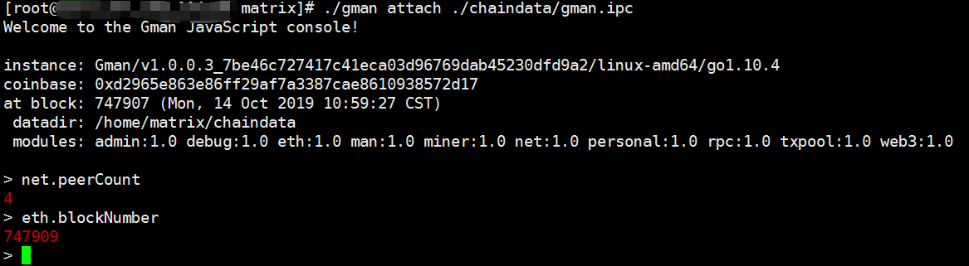

Windows
2.2.1 Download the latest version of gman at the address below.
www.matrix.io/dropdown_lord_cn.html

2.2.2 Download the latest snapshot file zip package at the address below.
www.matrix.io/assets/dropdown/TrieData5900000.tgz

2.2.3 Decompress the snapshot zip package to the snapdir folder under the same directory in the gman folder. Here let’s take decompressing tar xvf chaindata1342516.tar.gz as an example.

2.2.4 Launch gman and start syncing blocks.
- Type cmd in the Run Window to launch the Command Prompt. Enter the following string:
gman.exe --datadir chaindata --networkid 1 --debug --verbosity 5 --gcmode archive --outputinfo 1 -- syncmode full --loadsnapfile "TrieData1342516 "

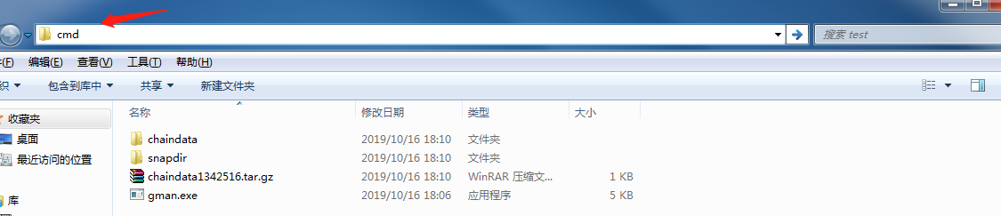

2.2.5 Check if blocks are syncing

a）Run gman.exe attach ipc:\\.\pipe\gman.ipc to launch the IPC interface.
b）Enter eth.blocknumber to check if blocks have started syncing. Snapshot height can be seen from the snapdir folder.
c）Enter net.PeerCount. View the number of peers. If there are no connected peers for five minutes, close gman and repeat the previous step. If there are connected peers, check if data is syncing.
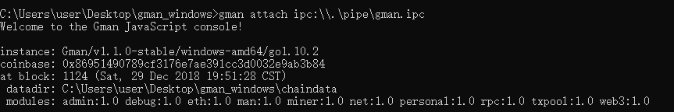

2.2.6 Transfer account data

a）Copy the keystore data file from the original computer. The keystore file can be found under the keystore folder. The keystore folder can be found under the chaindata folder, which in turn is under the gman folder.

b）Find the entrust.json file in the gman file of the original computer. Copy and paste it in the gman folder of the new computer.

c）Close the old gman file.

e）Open a new Command Prompt. Copy and paste the string below. Press Enter.
gman.exe --datadir chaindata --networkid 1 --debug --verbosity 5 --manAddress (Wallet Address) --entrust entrust.json --gcmode archive --outputinfo 1 -- syncmode full

2.2.7 Check if your gman is working
a) Launch the Command Prompt by typing cmd in the Run window. Enter the string below to launch IPC.
./gman attach ./chaindata/gman.ipc
b）Run net.PeerCount. View the number of peers. If there are no connected peers for five minutes, close gman and relaunch it. If there are connected peers, check if data is syncing.

Mac
2.3.1 Download the latest version of gman at the address below.
www.matrix.io/dropdown_lord_cn.html

2.3.2 Download the latest snapshot file zip package at the address below.
www.matrix.io/assets/dropdown/TrieData5900000.tgz

2.3.3 Decompress the snapshot zip package to the snapdir folder under the same directory in the new gman folder. Here let’s take decompressing tar xvf chaindata1342516.tar.gz as an example.

2.3.4 Launch gman and start syncing blocks.
Select the current working directory folder. Right click to create a new Terminal window. Enter the string below.
./gman --datadir ./chaindata --networkid 1 --debug --verbosity 5 --gcmode archive --outputinfo 1 -- syncmode full --loadsnapfile "TrieData1342516"

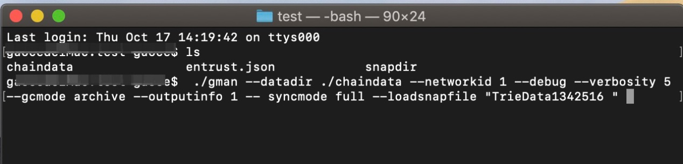
2.3.5 Check if blocks are syncing
a）Run ./gman attach ./chaindata/gman.ipc to launch IPC.
b）Run eth.blocknumber to check if blocks have started syncing. Snapshot height can be seen from the snapdir folder.
c）Run net.PeerCount. View the number of peers. If there are no connected peers for five minutes, close gman and repeat the previous step. If there are connected peers, check if data is syncing.

2.3.6 Transfer account data
a) Copy the keystore data file from the original computer. The keystore file can be found under the keystore folder. The keystore folder can be found under the chaindata folder, which in turn is under the gman folder.

b）Find the entrust.json file in the gman file of the original computer. Copy and paste it in the gman folder of the new computer.

c）Close the old gman file.

d) Open a new Terminal and enter the string below.
./gman --datadir ./chaindata --networkid 1 --debug --verbosity 5 --manAddress (Wallet Address) --entrust ./entrust.json --gcmode archive --outputinfo 1 -- syncmode full

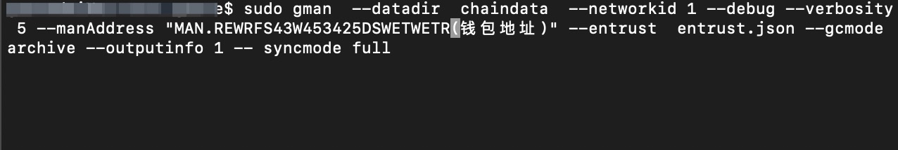
2.3.7 Check if gman is working
a) Run ./gman attach ./chaindata/gman.ipc to launch the IPC interface.
b）Run net.PeerCount. View the number of peers. If there are no connected peers for five minutes, close gman and relaunch it. If there are connected peers, check if data is syncing.

